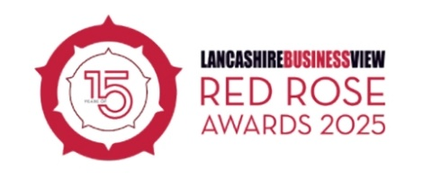

**PRESS RELEASE**

**[COMPANY NAME] victorious at Red Rose Awards 2025**

[COMPANY NAME] has prevailed at Lancashire Business View’s Red Rose Awards, winning the [AWARD CATEGORY NAME].

The Red Rose Awards are held in Blackpool every year, and play out in front of an audience of more than 1,000 business professionals. This event saw the awards celebrated for the 15th time!

Businesses from the length and breadth of the county vied for titles across a range of categories, with only the best of the best, as selected by a panel of expert judges, progressing through to the shortlist and a rigorous interview stage before being rewarded for their excellence.

[COMPANY CONTACT AT COMPANY] said: “[INSERT COMMENT] ”

Event founder Richard Slater, also the chairman of Lancashire Business View magazine, said: “The Red Rose Awards, now in its 15th year, are very hotly contested, so [COMPANY NAME] should be very proud that they have seen off all the competition to win this award!

“It was a great event and we look forward to seeing [COMPANY NAME] at our winners reception and the peer support sessions with Turnkey Corporate.”

As award winners, [COMPANY NAME] collected a trophy specially crafted by trophy partner PDS Engineering.

Presenter Graham Liver compered the evening, with entertainment from the Deadbeats, MH Productions and The Fun Experts.

Headline sponsors for the event were Forbes Solicitors and Barclays. The official judging partner of the awards was Burnley College and validation partner was RSM.

A full review and picture gallery will featured in the May/June edition of Lancashire Business View and online at [www.redroseawards.co.uk](http://www.redroseawards.co.uk)

The awards were also sponsored by: +24, BAE Systems, Bigtank, Blackburn College, Brysdales, Burnley Football Club, Campbell and Rowley, Chorley Council, Cube HR, Cube Thinking, D&M Creative, Farleys Solicitors, Harrison Drury Solicitors, High Court Enforcement, Mytton Fold Hotel, Napthens Group, Nybble, PDS Engineering, Peter Scott Printers, Pierce, PM+M, Porsche Centre Preston, Sales Geek, Shout Network, Sowena Group, The Fun Experts, Talentedge, Trident Utilities, University of Central Lancashire, Viva.

The awards are also supported by Community Foundation for Lancashire, RBC Brewin Dolphin, Marketing Lancashire, Merchandise4Impact, Worden Green Recruitment and Shout Connect.

Turnkey Corporate will be running peer-to-peer support and masterclasses sessions for Red Rose Awards finalists and winners as peer network partner.

The charity partner for Red Rose Awards 2024 was Lancashire and South Cumbria Hospices Together and funds were raised at the awards event to support their work.

ENDS

Lancashire Business View’s Red Rose Awards is the event where Lancashire business, commerce and industry are celebrated. It provides the best possible platforms to promote success, and to encourage trading within the county.

Since launching the awards in 2011 they have steadily grown and become the centrepiece attraction for the business community in the county with the sell-out ceremony taking place at the magnificent Winter Gardens Blackpool.

For further information please contact [insert company contact]

[www.redroseawards.co.uk](http://www.redroseawards.co.uk)

@redroseawards #RRA25